Analysis on Design Features of Chinese Character ErlangShen

Qing Huang,Donghyuk Choi

Department of Visual Contents, Division of Digital Contents
Graduate School of Dongseo University, Dongseo University
Busan, South Korea
820419734@qq.com, artistar@dongseo.ac.kr

Abstract

ErlangShen is a character in ancient Chinese fiction, used in various contents. The characters in contents can be understood through their characteristic colors. Thus colour analysis offers an insight into characters. This study analyzes the character of ErlangShen in ancient Chinese novels and draws from background theory and an understanding of the works to analyze animation which present the character. Thus colour analysis is presented as a method of character analysis.

Keywords-ErlangShen; Design; Characteristics

I. Introduction

Ancient Chinese novels present a diversity of characters and fantastic stories; they were propagated to neighboring nations. In areas of shared culture, the familiar contents have been widely used for animation (Fengshen Yanyi,许仲琳,명대) That nations with cultural consensus develop shared stories into contents can be seen as an aspect of the propagation of Chinese cultue and cultural exchange.
This study explores the character of ErlangShen, a character in ancient fiction. ErlangShen features in a wide range of animations such as <Daeyocheongung>, <Boryeongdeung>, <Journey to the West>, <Natajeongi>; the character plays an important role in story development. Thus an in-depth study through character analysis is required. In order to analyse the character, this study examines the characteristic features and colours in Chinese animation which feature ErlangShen. A way to apply such characteristics to creating characters that show China’s national character is also explored.
Research method and flow are as follows. First, the character of ErlangShen as in the Chinese novel Fengshen Yanyi is analysed, and with background theory and an understanding of the work, animiations which features ErlangShen are examined. This is to compare and analyse the stories and images in the original form of ErlangShen so as to summarize the features of the character in each animation. [1] Finally, based on this analysis, the colour analysis of ErlangShen character in various analysis is conducted to see how the traditional Chinese character is portrayed.
Animations studied in this paper are works based on China’s ancient shinma novels which are praised for publicizing ErlangShen character and lending faithful expression to China’s traditional aesthetics.

II. ErlangShen Character Design Analysis

- ErlangShen: Definition and History

ErlangShen (二郞眞君) stems from Chinese shamanistic and Taoist traditions. ErlangShen appears during Tang dynasty; it was used by the Song dynasty, along with Taoism, for the regime’s propaganda efforts.
There are two origin stories for ErlangShen. First, it is thought that he was the second son of a local minister Lee Bing (李氷) during the reign of King Soyang of Qin Dynasty (昭襄王, B.C. 307~B.C. 251) He is known for assisting his father in Guànxiàn (灌縣). Another origin story tells that ErlangShen was Cho Wook (趙昱), a minister of Gaju (嘉州) during the reign of Yangje (煬帝, 604-618) of Sui Dynasty. In a river of his jurisdiction, there lived a dragon which tormented people. The dragon, although like a serpent, had a horn and four legs, spewing poision to hurt people. So ErlangShen went out with a sword, jumped into the river without protection and after much struggle, killed the dragon to save his people. Afterward, he retired from public office and went into mountatins for an ascetic life until he event became a Taoist spirit. [2] People after him erected a shrine at Guankou (灌口), giving a rise to the title Guankou ErlangShen.
The character came to prominence with the novel Journey to the West. The ancient novel has been used for many reproductions with various adopted scenarios. In the novel, ErlangShen takes a peculiar form. Here, the sister of God descends to earth and marries a man called Yang and gives birth to a son – ErlangShen. In other words, he is the nephew of God. In the novel, ErlangShen follows an order from God to catch Son Wukong. He calls his men to order, takes an egale and dog, with a bow and arrows, then calls strong winds to cross the East Sea (東海) to Hwagwasan ((花果山: where Son Wukong lives). There, he engages in a dramatic duel with Son Wukong. They fight over 300 rounds but are unable to determine a winner. Then, ErlangShen shakes his body and transforms into a horrific feature, tens of thousands of meters high, with red hair, blue-black face, and sharp teeth. He lifts Samchumyangdoshinbong (三尖兩刀神鋒)to deal a final blow to Son. However, Son, being a shrewd monkey, mimics ErlangShen’s transformation and fights back. This fight again yields no wiiner,but ErlangShen begins to overwhelm Son; monkey start to flee. [3] Son, knowing he’s at disadvantage, abandons the fight and runs away.

B. ErlangShen in Animation

During the development phase of Chinese animation history, most works included ErlangShen. When Chinese animation blossomed, works such as <The Monkey King (大鬧天宮)> featured ErlangShen. <Lotus Lantern (寶蓮燈)> during revitalization phase and <Natajeongi (哪吒傳奇)> and <Journey to the West (西遊記)> during the wandering phase are representative works with ErlangShen.
Artists all express ErlangShen in their mind, or follow their childhood dreams, or respond to the call of zeitgeist, or attach themselves to conviction which transcends previous generations. [4]
<Table 1> shows the changing design of ErlangShen. Different times and changes in Chinese culture, production technology and philosophy have all affected the design of ErlangShen. In other words, the origin and evolution of ErlangShen design reflects the development of Chinese animation.

TABLE I
DESIGN FEATURES OF ERLANGSHEN CHARACTER IN ANIMATION

Year | Work | Features | Character
1961 | <The Monkey King>  <大鬧天宫> | 1.Traditional Chinese God  2.Sophisticated and slick | 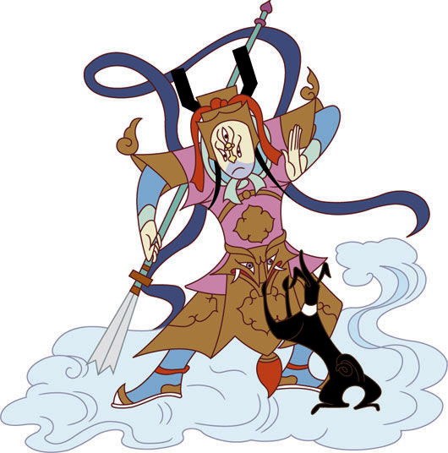
1998 | <Fengshenbang legend>  <封神榜傳奇> | 1.Similar to Japanese anime character  2.Detailed texture | 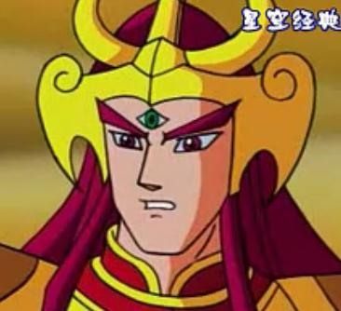
1998 | <Lotus Lantern>  <寶蓮燈> | 1.Stern lips, full of discontent  2. Portrayed as a villain | 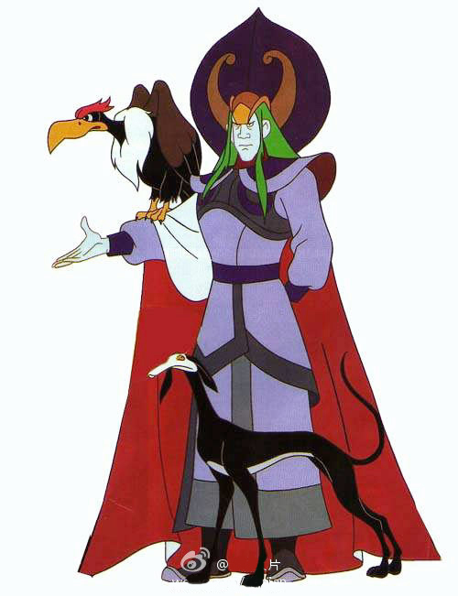
1999 | <Journey to the West>  <西遊記> | 1. Similar to Japanese anime style  2. Aspires to realistic portrayal | 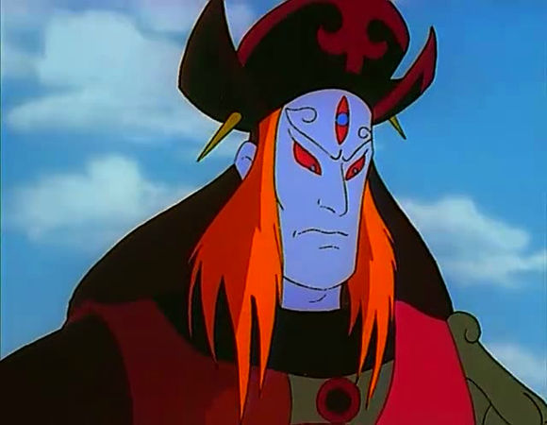
2004 | <Nata Jeongi>  <哪吒傳奇 > | 1. Thin figure  2.Involves many design features  3.Superb harmony of curved lines | 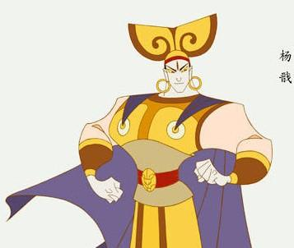
2013 | <Gunmok Jeongi>  <建木傳奇> 3D | 1.Realistic depiction  2.Natural action | 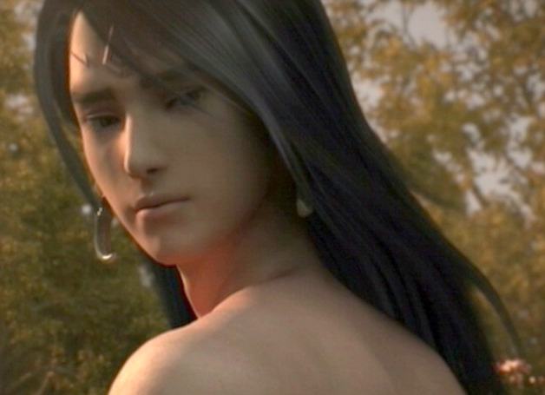
2015 | <Daesunggwirae>  <大聖歸來> 3D | 1. Depicted as a boy  2. Brave and manly  3. Chinese traditional style | 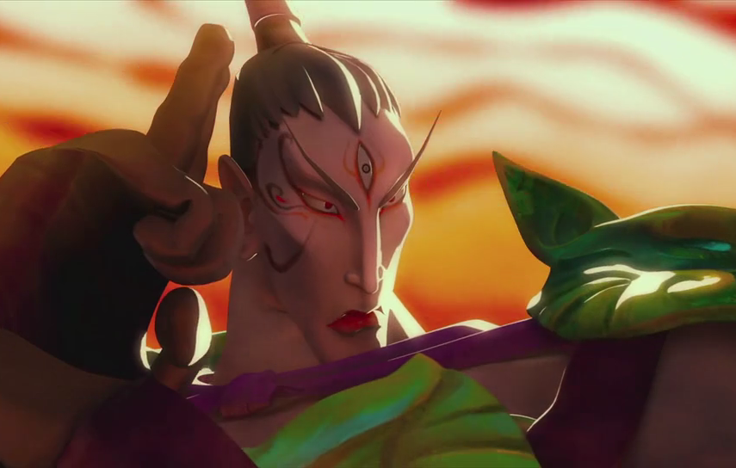

In fact, ErlangShen is one of the most accessible features in novels, and the design takes from descriptions in the novels. Hence the character are easily embraced by people and speak to the national character. This is why ErlangShen has been so widely loved.

III. Character Color Analysis

Three figures from Chinese ErlangShen animation have been selected for analysis. Color, brightness and chroma have been examined. Brightness and chroma in animation are analysed with L*C*ab graph, while color is examined using a*b* graphe. The result of brightness and chroma are as shown in <Table 2>.

TABLE II
BRIGHTNESS/CHROMA VALUE STANDARDS

L*C*ab value | Brightness | Chroma
0 ~ below 30 | Low | Low
30 ~ below 70 | Middle | Middle
70 ~ below 100 | High | High

The skin and clothing of ErlangShen showed L* axis value of 88, C* axix value of 56, showing Y-R colors of high brightness and middle chroma. [5] For hair, L* axis value was 18 showing low brightness, C* axis was 45 indicating middle chroma; Y-R color was used. The color analysis of ErlangShen text is shown in <Table 3>.

TABLE III
ERLANGSHEN CHARACTER SHIN RGB AND COLOR DISTRIBITION

Image | Color | Analysis Result
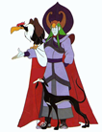 |  | 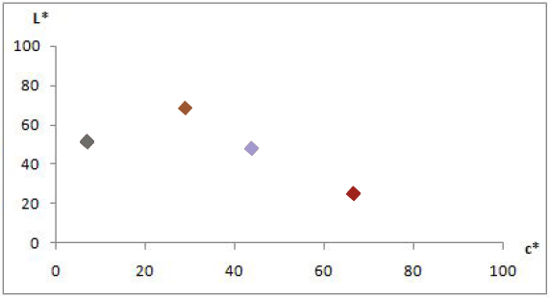  L*C*ab  Graph
 | 
 |  | a*b*  Graph | 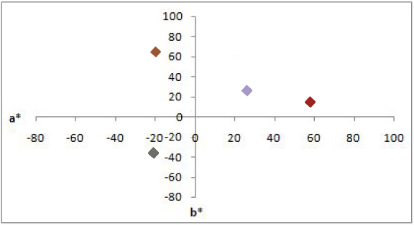
 |  | a*b*  Graph
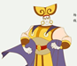 |  | L*C*ab  Graph | 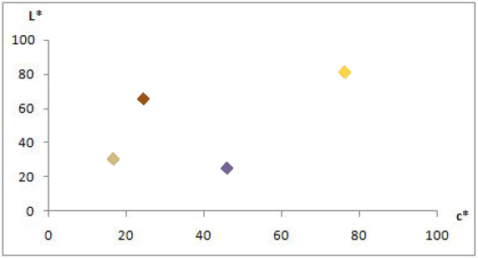
 |  | L*C*ab  Graph
 |  | a*b*  Graph | 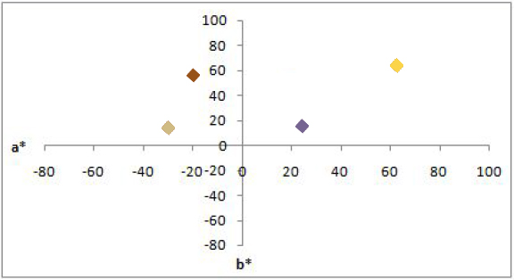
 |  | a*b*  Graph
 |  | L*C*ab  Graph | 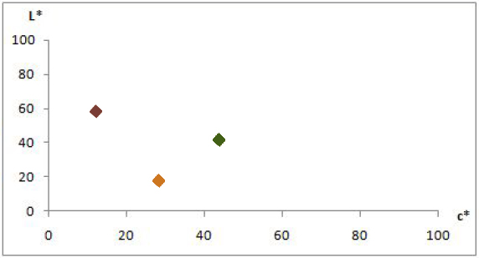
 |  | L*C*ab  Graph
 |  | a*b*  Graph | 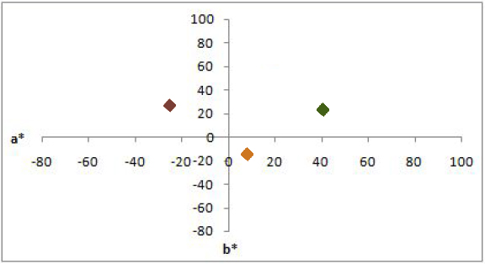
 |  | a*b*  Graph

ErlangShen’s text was mainly middle brightness and high chroma, with even color distribution. Background, character and text were similar at large, mainly showing colors of high chroma.

IV. Conclusion
This paper has examined ErlangShen character in various animations and presented a theoretical perspective on the role of color in animation. Also, various cases have shown the featurs of ErlangShen as portrayed in animation, indicating the characteristics and colors of ErlangShen character design.

The analysis reveals that ErlangShen is often portrayed in dark colors, low brightness and high chroma to show a strong and heavy character. If it is possible to read the personality of a character in its image, color analysis informs the process of color selection in character conceptualization. Research on China’s representative characters presents a way of understanding Chinese culture, preserves Chinese tradition and leads to various contents and researches. To this end, there needs to be a greater understanding of the breadth of Chinese culture. This research should serve to encourage more researches into the color of charcaters which represent China.

References

[1] Chen Liao, Five with five different of the Journey to the West and Legend of Deification, 2015, pp.8-15.
[2] Elangzhenjun Taoist Gods, Deulnyuk,2007, pp55-68.
[3] Chen Ling Lan , Elang shen Prototype history, unpublished 2013, pp.20-23.
[4] Long Ben Hong Zhi, Legend of Deification Images and their origins,2003,pp.20-34.
[5] Lim Hyeri , Study on TV program`s character design- Focused on emotional development of children, 2015,pp.8-10.

